**Mobile Applications Development 3**

**Project Design Document**

Designed by: G00303598 – Morgan Reilly

Game Title: Quick Fire

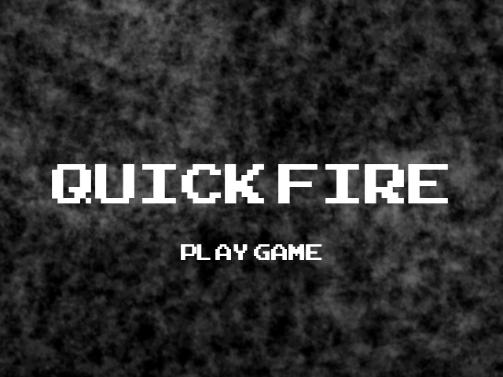

Appendices

1. Research and Choice
2. The Game
   1. Rounds / Waves
   2. Difficulty
   3. Score
3. Controls
   1. Menu Controls
   2. Player Controls
4. Main Menu
   1. Start Game
   2. Set Difficulty
   3. High Scores
   4. Settings Menu (See 5)
5. Main Settings Menu
   1. Enable / Disable: Music / Sound
   2. Controls
   3. About Game
6. Examples of Gameplay Design
7. Examples of Menu Design
8. Sprite List
   1. Game
      1. Player
      2. Background
      3. Screen Bottom
      4. Platforms
      5. Bullets
      6. Power-Ups
      7. Play / Pause (Mobile)
   2. Main Menu
      1. Directional Arrows
      2. Current Choice
   3. Settings Menu
      1. Display On / Off
   4. Controls Menu
      1. Spacebar / A
9. References
10. Research and Choice

Growing up I played my fair share of platformers and shooters. I have decided to combine both. There are a few games that came to mind such as Mario Bros (Platformer) (Ref. 1) and Asteroids (Shooter) (Ref. 2) that I have drawn inpiration from and have decided to attempt to combine both. In the process of developing the idea I was reminded of Frogger (Platformer) (Ref. 3) , which I feel the game resembles the most. However, I have tweaked it so that there is now gravity and the objective is for the player to survuve wave after wave of bullets, jumping from platform to platform, rather than crossing a road to avoid traffic.

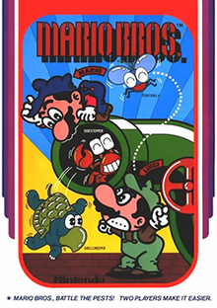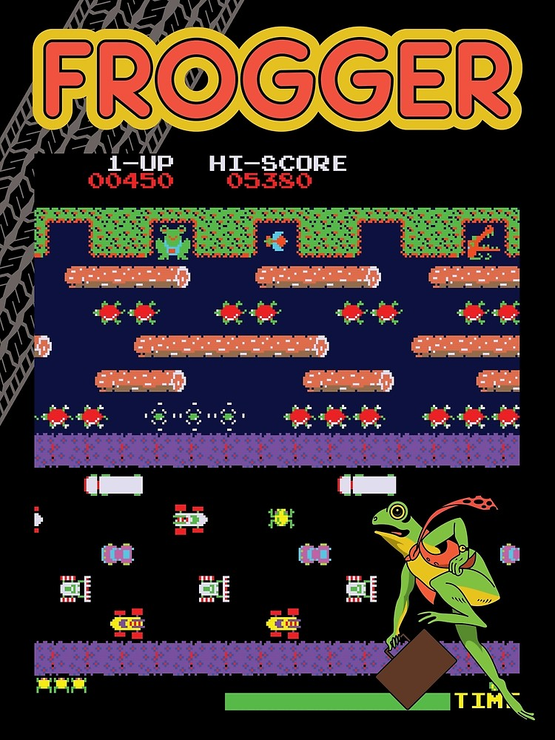

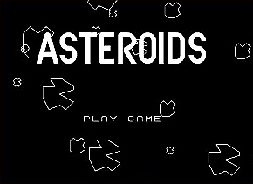

2. The Game

The game is to jump from platform to platform, avoiding oncomming objects (bullets) from the right side of the screen.

The design of the game is to be retro.

The game has no objective apart from a highscore.

If the player is hit, it removes a life, unless the lives are at 0; then the game ends.

If the player falls off the platform and subsequently off the screen a life is deducted. If the player has remaining lives then they are respawned on a random platform. If the player has 0 remaining lives then the game is over.

The game ends when the player has <0 lives i.e. should the player have 0 lives and is hit, the game should end.

Once the game ends it should display the text “Game Over” along with the socre achieved by the player and the round they got to.

2.1 Rounds / Waves

Rounds should start slow in both number of objects fired and the speed of the objects fired.

Rounds end once all of the objects fired have passed off the edge of the screen to the left and the player has >= 0 lives.

1. (Round 0-5) These rounds should begin easy and introduce the player to the game. These rounds should start at 10 bullets and increase by 10 each round. The bullets should start with a low speed and should gradually increase per round.
2. (Round 5-10) These rounds should be regarded as quickfire rounds. The number of bullets should increase by 10 each round but the speed should be doubled for the 5 rounds.
3. (Round 10-15) These rounds should see the introduction of the platforms dissapearing and reapearing every 5 seconds for 2 seconds. It should keep this consistancy for these 5 rounds. The bullets fired should increase by 10 and the speed should no longer be doubled for these rounds but should be increased gradually by 10 bullets per round to keep the difficulty up.
4. (Round 15-20) These rounds should see the introduction of a power-up. This power-up should only appear once per round and adds a life to the player. These rounds should be considered quickfire rounds also with the speed being doubled in a similar fashion to B.
5. Finally the levels should be infinite and can be built in the fashion {A,B,C,D,C,D,C,D,...}, increasing difficulty each round.

2.2 Difficulty

The difficulty of the game is based on the lives the player gets to start with. This can be chosen in the main settings menu. The game should progress normally regardless of choice.

The difficulties the player can choose are as follows:

* Easy: 3 Lives
* Medium: 2 Lives
* Hard: 1 Life
* IRL: 0 Lives

The default difficulty should be set to: Hard.

2.3 Score

Score is kept by tracking the number of bullets that exit the left side of the screen.

The bullet frequency is explained in 2.1 A-E

3 Controls

The game should use directional arrows and buttons to control the player and navigate.

The controls should be platform specific but ultimately will be very similar in design.

On mobile there should be a play / pause button on the top right of the screen, the PC version will use a key to play / pause the game.

3.1 Menu Controls (Fig. 9)

PC Controls:

These controls are for both the main manu and in-game menu:

* Directional Arrows - Navigation (Up, Down)
* Enter - Select an option
* Return - Go back a page

Mobile Controls:

* Directional Arrows - Navigation
* A - Select option
* Return Arrow (Top Left Corner) - Go back a page (Fig. 6)

3.2 Player Controls (Fig. 8)

PC Controls:

* Directional Arrows - Control player
* Space - Jump
* P - Play / Pause

IF: P pressed while the game is in play --> Bring to the in-game menu

IF: P Pressed while in the in-game menu --> Bring back to the game

Mobile Controls:

* Directional Arrows - Control Player (Left, Right)
* A - Jump

Game should have play / pause button in order to access menu / return to game.

4. Main Menu (Fig. 4)

On initial start the player is met with a menu that displays the options:

* Start Game
* Set Difficulty (See 2.2)
* View High Scores
* Settings

4.1 Start Game (Fig. 4)

Pressing this option starts a new game. User is advised to set a difficulty before starting but this is not necessary as game will default to Hard.

4.2 Set Difficulty (Fig. 5)

This option should allow the user to select a difficulty from the 4 options listed in 2.2

4.3 View High Scores (Fig. 6)

This option should display all scores, highest first, in a text format.

4.4 Settings Menu (Fig. 7)

The settings menu contains the following:

* Enable / Disable music
* Enable / Disable sound
* Controls
* About game

5. Settings Menu (Fig. 7)

This settings menu should be accessible from both the in-game menu and the main settins menu.

5.1 Enable / Disable: Music / Sound (Fig. 7)

This option should be available to either enable or disable the music or sound serperately, should the player wish.

5.2 Controls (Fig. 8, Fig. 9)

This option should display a picture of the controls the player can use, but not modify.

This option is platform dependent i.e. if the user is on PC it will display the PC controls. If the player is on mobile, then the mobile controls are displayed.

5.3 About Game

This option should display a text box with some info about the game, developer, designer, licence (if used), year developed etc. (I have excluded design of this purley because it is literally just a box with some text)

6. Examples of Gameplay Design (Fig. 1 - 3)

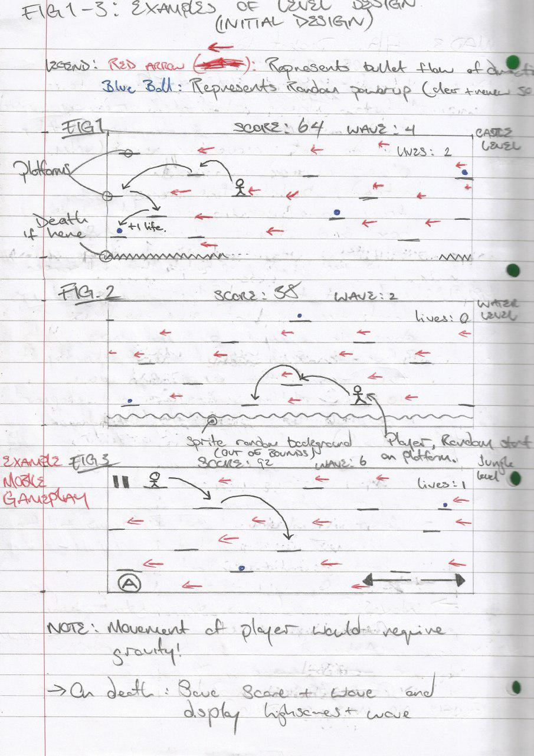

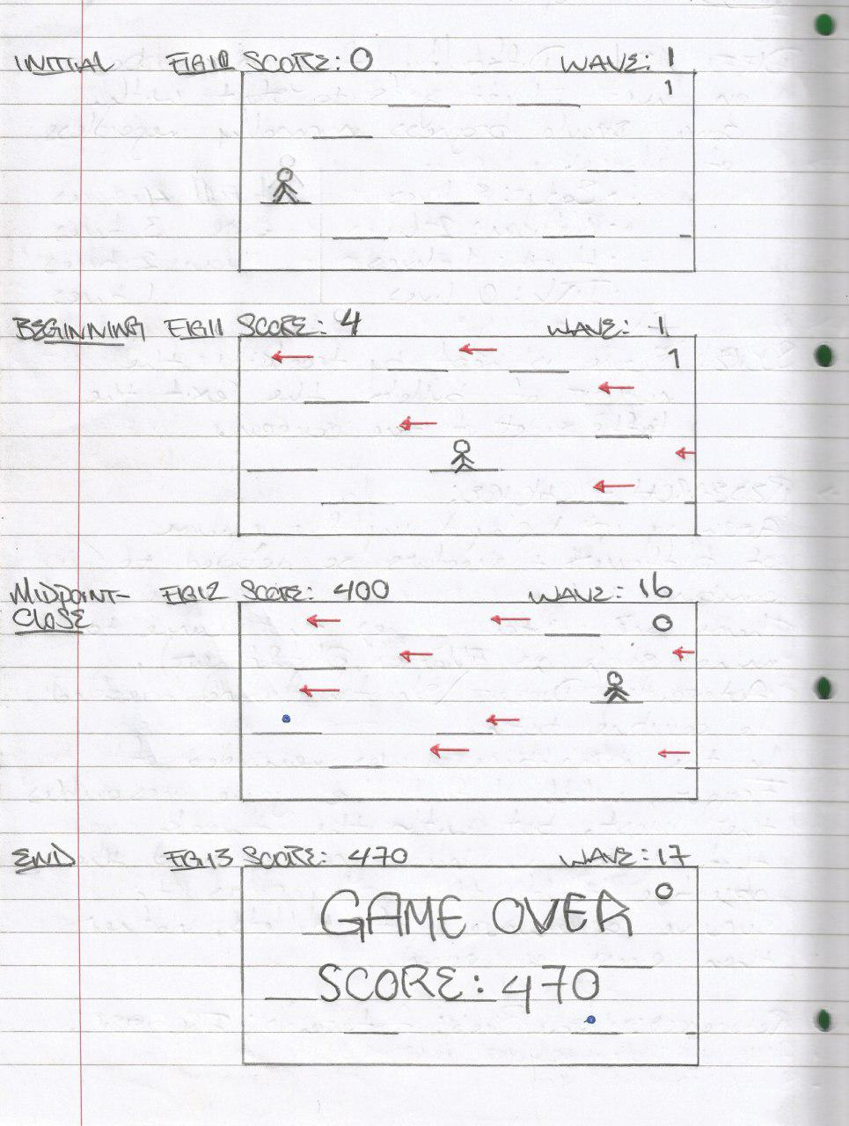6. Examples of Gameplay Design (PC) (Fig. 10 - 13)

7. Examples of Menu Design (Fig. 4 - 5)

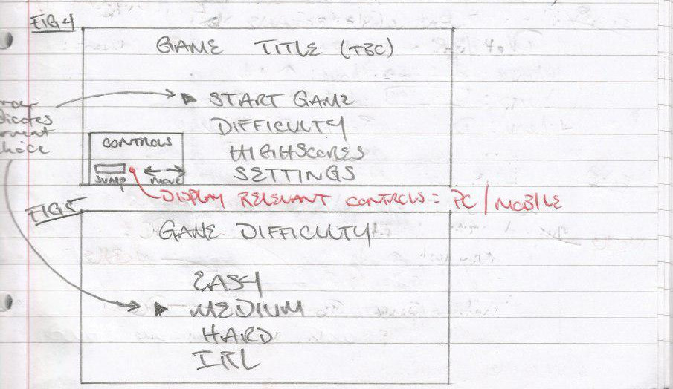

7. Examples of Menu Design (Continued) (Fig. 6 - 9)

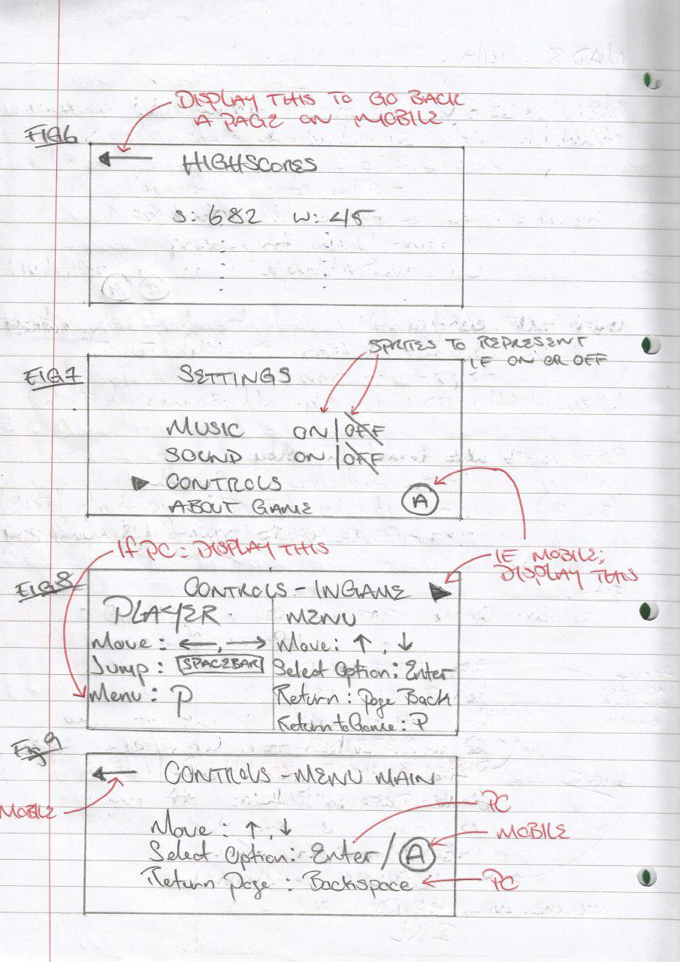

8. Sprite List

8.1 Game Sprites

These are the sprites to be roughly followed in-game, the below list are just examples. They ultimately only come down to some basic shapes, such as rectangles, triangles, cirlces and squares as I would like this game to feel retro.

8.1.1 Player

The player can be as simple as a stick figure. However, there should be 2 states for design. The first being stationary, the second being in motion to represent the player jumping in a direciton.



8.1.2 Background

The background can be any image the developer wishes. In the gameplay examples given (Fig. 1, Fig. 2, Fig. 3), they’re meant to be a castle level, water level and jungle level, but can be whatever the developer wants.

8.1.3 Bottom Of Screen (See Fig. 1 - Fig. 3)

This should be an area to represent the out of bounds. (See Fig.1). This can be as simple as a row of triangles (spikes) or semi-circles (water) to represent an area the player shouldn’t be able to stand on. Or alternately leave empty to represent being high up in the air.

8.1.4 Platforms (See Fig. 1 - Fig. 3)

These should rectangles be twice the width of the player. Colour depending on level design i.e. if the level is a jungle; then have the platforms be brown to represent branches.

8.1.5 Bullets (See Fig. 1 - Fig. 3)

These can be as simple as gold coloured rectangles. (See Fig. 1 - Fig. 3). Ideally they should have a point on them so the player can identify them as bullets but this can be ignored if the developer wishes.

8.1.6 Power-Ups (See Fig. 1 - Fig. 3)

These should be blue circles so the user can identify them as a power-up.

8.1.7 Play / Pause (Mobile) (Fig. 3)

Play should be a single black triangle

Pause should be 2 black vertical rectangles.

8.2 Main Menu (Fig. 4)

8.2.1 Directional Arrows

These are used to display the controls in menu and similar should also be used if they player is on mobile.

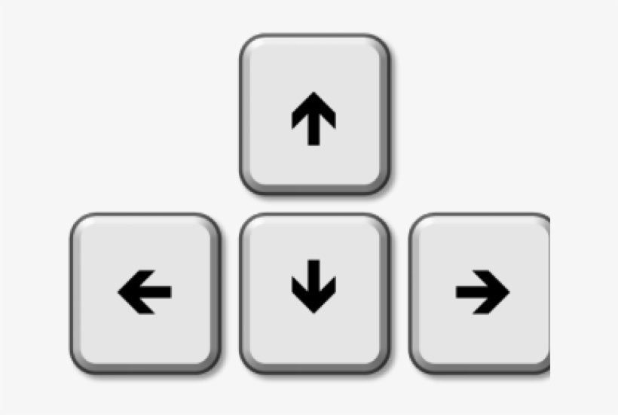



8.2.2 Current Choice (Fig. 4)

This is the same as the play option for mobile. Single black triangle to represent current choice in the menus.



8.3 Settings Menu (Fig. 7)

8.3.1 Display on / off

These should be simple switches to represent if the sound or music is currently on or off. This should be used in both main menu and in-game menu.

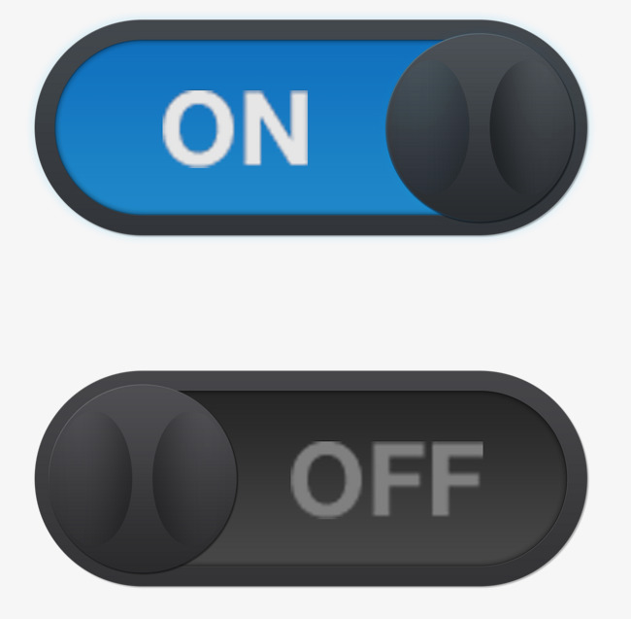

8.4 Controls Menu

8.4.1 Spacebar / A / Enter

These controls are platform specific.

If the player is on mobile then they will use A to jump and select an option.

If the player is on PC then they will use the spacebar to jump and the enter key to select an option.

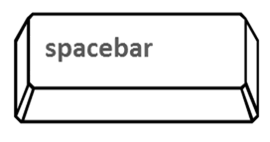

9. References

(Ref. 1) Mario Bros: <https://en.wikipedia.org/wiki/Mario_Bros.>

(Ref. 2) Asteroids: <https://en.wikipedia.org/wiki/Asteroids_(video_game)>

(Ref. 3) Frogger: <https://en.wikipedia.org/wiki/Frogger>

